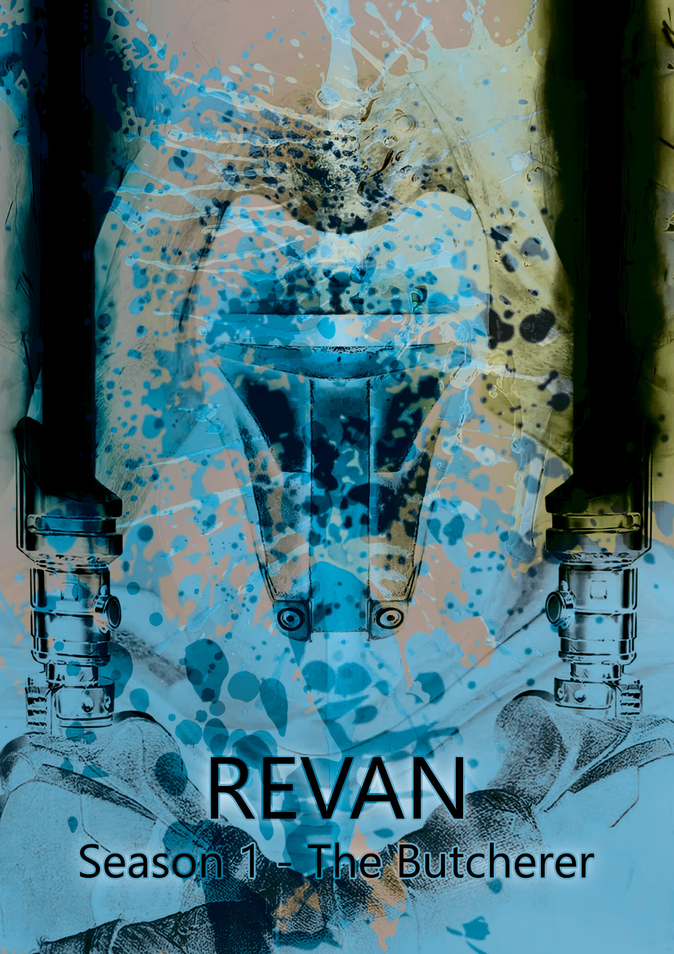

Episode 10 – Finale – Betrayal

We open to Revan walking through star forge to pure cocaine by lil baby. The walls breathing like before, the robot zombies manufactured in Star Forge surround him as he walks. They walk mindlessly with him. He comes out to the training dojo and watches Ekhralon and Zeravûn duel in the ancient Sith style. Zeravûn’s lightsaber is a black void blade, viridescent, a white pearl color with green hues swirls inside of it, like stars in the galaxy, completely unseen before in canon. His handle is a blood red metal tone with prongs extending up the blade slightly. It makes a lighter pitched noise, almost as if it’s not on as he swings it and ignites it. The song fades out as Ekhralon beats Zeravûn and Revan smiles. Revan then says:

“The sith empire has asked me to retrieve an ancient Sith relic from a Jedi temple, I thought you’d like to come.”

Zeravûn says:

“Ancient Sith Relics? My specialty. What are we stealing?”

He says:

“It’s a cup, used by an ancient Sith lord, apparently.”

Zeravûn laughs and says:

“I’ve been meaning to get another one.”

Ekhralon says:

“Didn’t we get this mission months ago?”

Revan says:

“I’ve been avoiding it and now we kind of have to.”

Zeravûn says:

“An ancient sith relic that you’ve been avoiding? What could frighten you?”

Revan pauses and says:

“It’s ah-“

He takes a deep breath and says:

“It’s in a temple, on Malachor V.”

Malak stands up and says:

“No. We’re not going back.”

Revan says:

“We have to, we’ve been ordered to.”

Malak starts to stress out he says:

“Why? Because the Sith empire told us to? When have we ever done anything because we were told to?”

Revan says:

“Calm down Malak, we’ll be in and out.”

Zeravûn says:

“Malachor V was where the war ended, are you sure you can go back?”

Ekhralon says:

“Wait we’re going to that planet?!”

Revan gets frustrated and leaves saying:

“Just get your stuff and stop asking complicated questions.”

We swipe cut to Bastila who’s looking out to Malachor V, the ripped planet glowing through the window. Seravé says:

“What happens if they show up?”

Bastila sighs and says:

“We’ll have to shut down the ship completely, there are some old Jedi ships still intact abandoned in orbit so we just blend in.”

Seravé says:

“And if they spot us?”

Bastila walks up to Seravé and sits next to her. She sighs and says:

“Let’s plan for success and go from there.”

Seravé looks concerned. Bastila says:

“Did you get any sleep?”

Seravé says:

“No I haven’t been able to relax ever since we’ve arrived.”

Bastila says:

“I know how you feel.”

Seravé says:

“Why does the planet to that to us?”

Bastila says:

“You know how midicolorians carry the force in all living things correct?”

Seravé says:

“I do.”

Bastila says:

“Well, when billions of people die all of a sudden in an act of genocide, it tends to create a ripple in the force, or in this case…”

She looks out at the planet:

“A chasm.”

Seravé says:

“That’s why we can sense them?”

Bastila says:

“That’s why we can hear them yes.”

A girl’s scream rips through the ship’s walls, echoing off them.

Bastila says:

“We can’t stay much longer.”

We cut back to Revan and the group in hyperspace, Malak in one ship with Zeravûn, Revan and Ekhralon in another, we start on Revan and Ekhralon in Revan’s main ship. He's spinning his red lightsaber hit in the air, playing with it. Making it flow through the air. Ekhralon says:

“Why are you so afraid of Malachor V? It’s just a planet.”

Revan sighs and grabs his hilt and stows it as he says:

“Ek, Malachor V isn’t just a planet, when the Shadow Generator went off it killed billions.”

Ekhralon says:

“Yeah I know.”

Revan says:

“Which creates a schism in the force, it’s one of the darkest places in the galaxy.”

Ekhralon says:

“Strong in the dark side?”

Revan laughs and says:

“Oh no, no, no this is different, it’s a tear and we have no idea what kind of monsters have been created from it.”

Ekhralon pauses and says:

“That’s why you’re so on edge.”

Revan says:

“Well there’s that, and the obviously difficult memories of war bit which doesn’t help.”

Ekhralon says:

“You regret the Mandalorian wars?”

Revan pauses and says:

“Everyone regrets war, it doesn’t matter what side you’re on, that’s why there hasn’t been a Sith-Jedi war in 2000 years and everyone tries to avoid it.”

Ekhralon says:

“They wouldn’t remember.”

Revan says:

“True, but we have holocrons, pieces of data that don’t get corrupted, and have seen what horrors that war brought upon the galaxy.”

There’s a pause. Revan then finishes and says:

“I’ve seen war, I’ve fought in war, I’ve ended war, and yet I still regret the war even though I lived. The dead have it easy, they don’t have to live with the memory.”

We see Ekhralon’s face go still as we fade to Zeravûn in Malak’s ship. Malak says:

“You ever been to Malachor V?”

Zeravûn says:

“Never, not even when it was still a planet.”

Malak says:

“If you see ghosts, ignore them.”

Zeravûn says:

“Ghosts?”

Malak stands up and pours a drink as he says:

“The force ghosts, remnants of war, innocents, mandalorians, good, evil, friends and enemies, they’re all there. They all try to tempt you.”

Zeravûn pauses and says:

“I’ve seen war before. I’ve read about more, what makes the Mandalorian war any different?”

Malak says:

“It isn’t different to old wars, except how it ended. Most wars you read about, many people die true, but not all at once. It’s over time, maybe 2000 in a battle which creates some of the most cursed artifacts in the galaxy. This was billions.”

Zeravûn says:

“Creating a schism in the force.”

Malak downs his drink and says:

“Exactly.”

Zeravûn watches him sit back down and Malak says:

“Just don’t speak to the ghosts.”

We cut to Bastila in her ship pacing back and forth. Seravé says:

“We should just leave Bastila.”

Bastila says:

“Just a little longer we’ll be fine.”

Seravé says:

“It’s taking a toll on everyone not just you.”

Bastila says:

“We need to stay calm, we need to stay strong and wait it out.”

Seravé says:

“Bastila, are you ok?”

Bastila starts to hallucinate, a figure walks out of the door near her control room. It’s blurred but looks like darth nihilus, the whispering of sith runes can be heard. He walks through the room and Bastila runs in front of Seravé and says:

“HIDE!”

Seravé looks in front of her and says:

“There’s nothing there, Master.”

Bastila shouts:

“I SAID HIDE!”

Seravé turns to her and says:

“You’re starting to scare me.”

Bastila starts to become unconscious and faints, she hits the floor as we smash cut to Revan and Ekhralon in his ship. They drop out of hyperspace. We see Malachor V in the window. Revan looks out and puts on his mask and says:

“Welcome to my creation.”

Ekhralon looks out and hears the screams and starts to tear up. She says:

“This is Malachor V?”

Revan just looks out as they fly closer. We see Malak’s ship drop out of hyperspace and Zeravûn stands up looking out and says:

“I’ve never felt this before…”

Malak says:

“This was the end of the Mandalorian war.”

Zeravûn puts his fingers out and feels a force ripple, it screams at him in response. He retracts his arm rapidly and says:

“It’s just pain.”

Malak says:

“Exactly, just pain...”

We cut to Bastila’s ship, Seravé runs over to the intercom and shouts:

“SHUT IT DOWN NOW!”

The ship starts to shut off, she runs over to Bastila and holds her head and says:

“Master! Please! Please wake up!”

She looks out at the ships flying into orbit of the planet. We follow the ships and cut to Revan as the ship lands and everything goes quiet. Revan sighs and the doors open to a waste land. He steps out of the ship and puts his land out to Ekhralon. She grabs it and follows him with a helmet on. They both look over to Malak wearing a Mandalorian helmet like Revan’s and Zeravûn using a force bubble. They set out and join them. They stand there as force ghosts appear around them. A ghost appears screaming and reaching for them as it gets crushed by a piece of metal. Ekhralon flinches in response. Zeravûn says:

“I’ve never seen something like this before…”

Revan starts walking and puts his hand through the mist as screams can be heard around them. There’s a young girl being held by a terrified mother as a Mandalorian fires upon them. Revan turns around, puts his arms out and says:

“Welcome to the Mandalorian wars. It’s my pleasure to be your guide.”

He turns around coldly, and the group start walking. We see different scenes as they walk through the fog, Sith and Jedi alike dying at the hand of each other and the Mandalorians as horror tones play with the screams of people echoing around the planet. Ekhralon watches a padawan girl get killed by a Sith lord. She says:

“Why are there force ghosts?”

Malak says:

“People trapped, unable to die. Forced to relive the same day over and over again.”

An entire building collapses on top of them and fades. Zeravûn and Ekhralon both react but Revan and Malak don’t. Zeravûn says:

“You’ve been back before?”

Malak says:

“We had to see it once, we were supposed to never return.”

There’s a tall obsidian structure that appears out of the fog. Revan kneels. We see a tear drop from his mask as screams can be heard around, becoming more intense. The ghosts start to grab at him as the obsidian structure opens. There’s a pause as it opens fully. Revan stands and indicates and says:

“After you.”

They start to enter, and right as Revan is about to enter last, he stops and looks to his right. We see a specter of Darth Nihilus walk through the fog and disappear. Revan says:

“What are you?”

Nihilus’ neck snaps staring at him. His body whispering. Malak then shouts:

“Revan! Come on!”

He looks away and then back out at Nihilus, he’s gone. He enters the temple. The walls completely black but open to a white color as they enter. The blade is in the center of the room. Malak says:

“There’s usually a test with these…”

Revan says:

“I doubt it.”

Malak says:

“Are you sure?”

Revan says:

“It predates even early Jedi, this was built by a Korriban… *he pauses* Still though, watch your step.”

Revan walks towards the blade slowly as a tense sound starts to build. He slowly makes his way to the blade and pulls it out of the rock in the center. The rock turns to ash Revan is transported to a black void. The sound of whispering behind him. He turns to see Nihilus as close as before.

The voice echoes around the void:

“I am your fault.”

The body smiles as it continues to whisper and the voice echoes again.

“Welcome home.”

The void drops suddenly, and Revan is frozen in the middle of the room.

Zeravûn says:

“So… now back to the ship?”

Revan says:

“The less time we spend here the better.”

As he walks out handing Malak the sword.

We cut back to Bastila who’s woken up now and is taking deep breaths as she sits on a couch. She stands up and almost falls over. He makes her way to the intercom and says:

“As soon as the ships come back from the planet, fire up the ship and fire on Revan’s command ship, it’s the larger one. Try and hit the engines yeah?”

She collapses onto the ground. Seravé smiles with tears in her eyes, she says:

“We’re almost there. It’s almost over.”

Bastila smiles and says:

“We’re finally going to win.”

She starts to tear up. Seravé hugs her. The ships come up from the planet and Bastila stands up hurriedly and says into the intercom:

“NOW!”

The ship fires up and fires on Revan’s ship disabling it. We cut to Revan and Ekhralon who’s ship’s engines explode and the entire ship shakes. Revan looks down at the control panel and shouts:

“SHIT! THE ENGINES ARE DOWN!”

He runs into the back and Ekhralon looks out at the Jedi ship flying towards them. Ekhralon turns to run back to Revan. The Jedi ship flies next to Revans and a bridge is created from the ship. Bastila leads to force of drained Jedi and says:

“Alright, this is it! Stay close!”

She sticks her light saber in the doors of his ship and they open. They charge inside and she corners Revan. He starts to back up with his hands up as Ekhralon comes running in and crashes into him falling back. She hurriedly gets up and watches, Bastila says:

“You’re fast, but do you think you’re that fast?”

Revan says:

“I could be.”

Bastila lies and says:

“There’s 30 other ships surrounding us, and your ship’s disabled.”

Revan pauses and says:

“I could take them.”

Bastila says:

“I highly doubt that.”

Revan laughs and says:

“You think you’ve won?”

We cut to Malak who comes flying back to Revan. He says:

“Shit the Jedi have boarded him!”

Zeravûn raises an eye brow and says:

“Your chance is now Malak. You can save your friend or take your place as the leader of the realm of shadows.”

Malak stops looking out to the two ships. We cut to inside. Revan still backing up says:

“Let’s think about this Bastila. Who’s left to fight if I’m captured huh? What will you do?”

Bastila laughs and says:

“I’ve finally got you. I will not let you talk me out of this.”

Ekhralon pulls her lightsaber and Bastila force throws her against a wall, her lightsaber falls to the ground. Bastila’s eyes flash yellow for a second. Revan says:

“Please. Don’t hurt her.”

Bastila says:

“Oh so you showed mercy to all those padawan you killed?!”

Revan says:

“Come on you’re a Jedi Bastila, you wouldn’t fall to the dark side.”

Bastila’s eyes go yellow and she shouts:

“You have no idea what I am capable of when pushed!”

Revan backs up turning off Ekhralon’s lightsaber with the force.

All sound drops, just them in a hallway and then a voice comes over the intercom of his ship. We cut to malak who’s holding down a button, he says:

“Revan, thank you for everything.”

We see Revan’s face look up to the speaker. Malak says:

“You were a good leader, and a better friend.”

Revan realizes what’s happening, looks at Bastila and says:

“Fuck-“

Malak’s ship starts to fire on both. Their bodies go flying as the ships explode, Bastila grabs Revan and force pulls Ekhralon towards her. She shields her and uses Revan as a shield as they fly into the vacuum of space. She tries to keep Revan alive as they fly into the vacuum of space, a force bubble keeping her and Ekhralon alive as Malak’s ship turns and enter hyper space. We see the three of them, Revan’s body broken and ripped, bleeding. Bastila says:

“NO! You don’t die that easily!”

Ekhralon is unconscious in her arms. We cut to Seravé inside of one of the escape pods as the group rolls past, she knocks on the glass and Bastila pulls it towards them. All three get in and Ekhralon falls to the ground. Bastila kneels next to Revan and says:

“Check on her!”

Seravé checks her pulse and says:

“She’s alive master.”

Bastila sighs and has her hand over Revan’s chest. She says:

“I can only keep him stable so long, send a distress signal now!”

Seravé runs over to the control panel and activates the distress signal as the screen fades to black. We hear life support beeps, as the screen fades back in to a white hospital, Revan is lying with a breathing tube down his throat and wrapped up. Ekhralon stands by the window watching him. Bastila walks up next to her and says:

“You care about him?”

Ekhralon says:

“If you experienced what I did, you would to.”

We cut to Malak sitting in the throne in star forge. Zeravûn walks up to him and says:

“It suits you well.”

Malak smiles and says:

“Now it’s time for a real war.”

The screen smash cuts to a mashup of scenes as Bleach by Zillakami plays, the king sitting in his colloseum seat laughing and eating as his wife sits silently as they watch the games. Nihilus walking through the ghosts of Malachor V, force draining them, making them dissapear as an Aang tii monk watches on from a distance, Meetra on a ship drinking tea looking at old images of her with Reven when they were younger knights, Kreia spinning 3 purple lightsabers around her dressed in black, a tombstone on tatooine dedicated to the boy who lost the race, his mother standing in front of it in all black, alone. Finally, back to Revan’s face, eyes closed, slowly zooming in, and right as the the next part of the song is about to start is eyes open and we smash cut to credits.

Post credit scene:

We see Darth Nihilus walking through star forge spinning his coin and whispering. A sith lord lights his lightsaber and suddenly smashes into the ground, nihilus’ has his hand extended and a voice echoes around the room:

“Where is he?”

Smash cut to black.

